klugWerks Installation and Configuration

Version-1

|  |  |
| --- | --- |
| **Prepared By:** | Dhivya Shanmugaraj |
| **Technical Lead/Manager:** | Dhivya Shanmugaraj |
| **Dated:** | 24th January 2019 |
| **Review BY:** |  |
| **Review Date:** |  |

|  |  |
| --- | --- |
| **Abbreviation** | Description |
| **ELMT** | **E**nterprise **L**andscape **M**anagement and **T**ransformation |

1. **Installation Tools:**

klugWerks is installed using the following tools:

* **IDE-Eclipse Oxygen 2**
* **Programming- Java version 8**
* **Application Server- Jboss 4.2.2**
* **Database – SQL server 2012**

1. **Configuration:**

The following are the steps to configure and run the klugWerks which is one of the derived products from ELMT in Eclipse IDE.

Step 1:

Go to Eclipse installed folder and open eclipse.

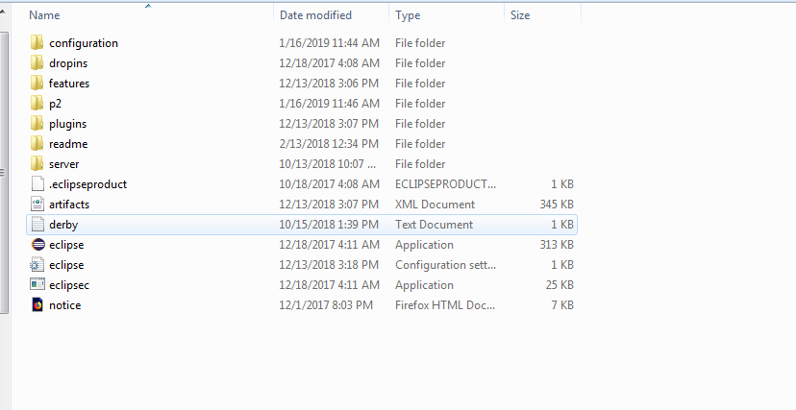

Step 2:

Now, browse for the workspace instance which you have created for configuration. For e.g. create a new folder (which is the workspace) in your preferred drive and copy and paste or browse the workspace.

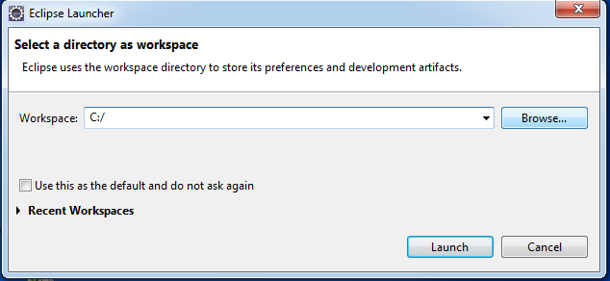

Step 3:

Then the corresponding workspace will be opening.



Step 4:

Below is the current workspace in the eclipse. It is empty as no project has been configured yet.

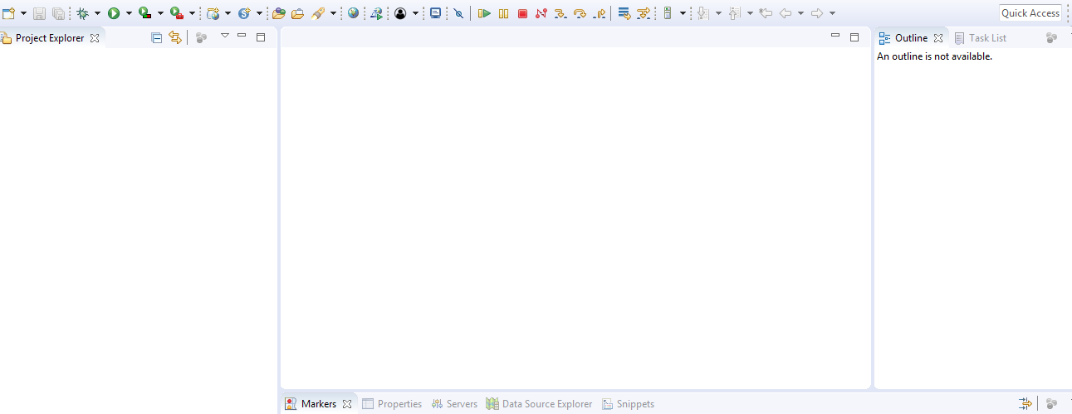

Step 5:

Now import the existing source from the desktop into the newly created workspace as File->Import

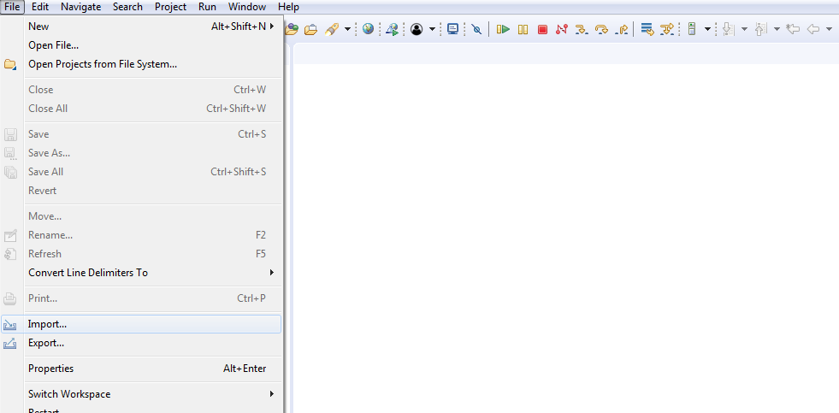

Step 6:

Select the “Existing Projects into Workspace” option and click next.

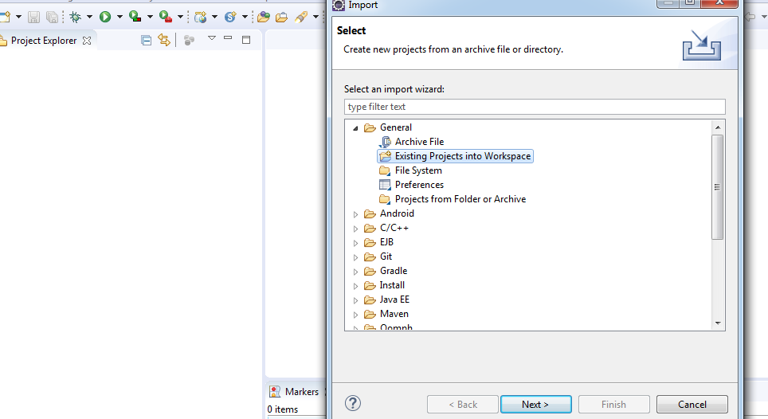

Step 7:

Then browse for the existing source and check the option “Copy Projects into workspace” and click Finish.

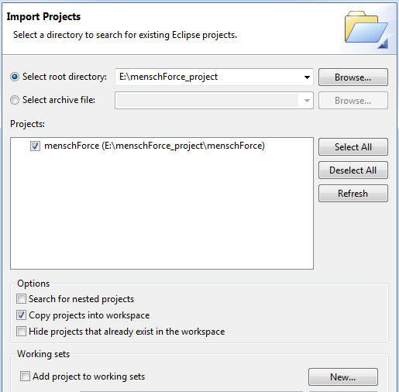

Step 8:

Now the klugWerks project is imported as shown below

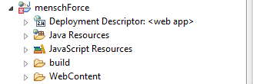

Step 9:

Now configure the libraries to the project. Right click the klugWerks->select properties

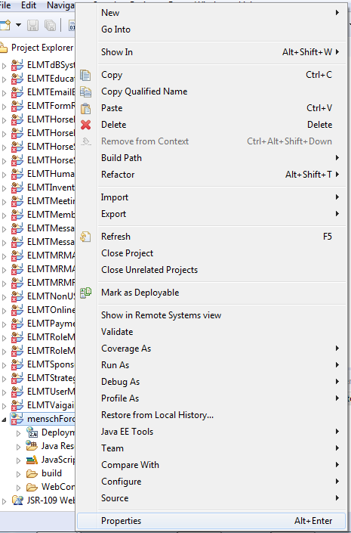

Step 10:

ELMT’s module jars are added in the lib folder and configured.

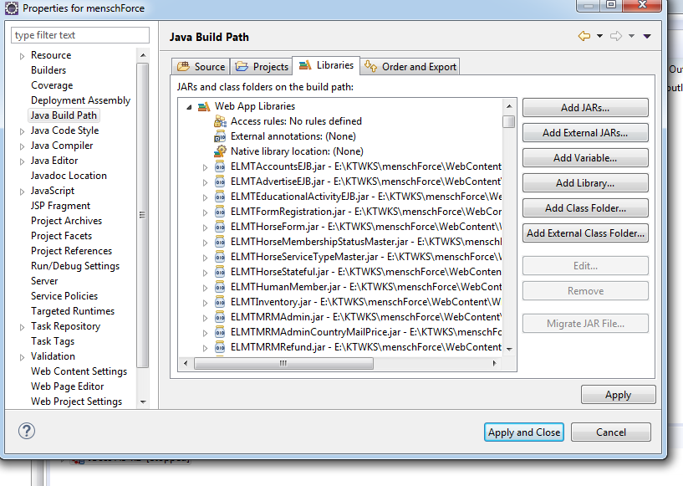

Step 11:

Next, add the new server into workspace and configure it to the project. Click servers tab.

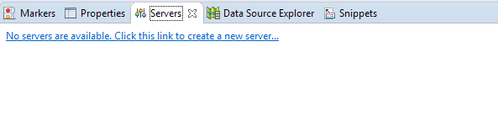

Step 12:

Select Jboss AS 4.2 with the default values and click Next button.

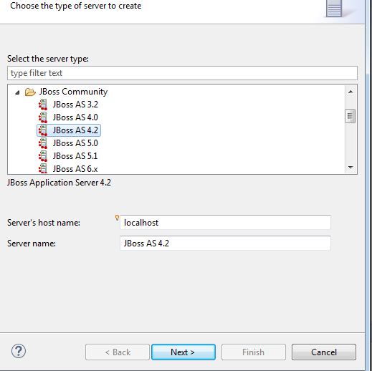

Step 13:

Let be with default values and click Next.

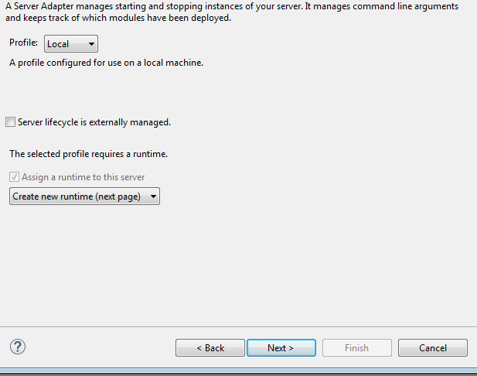

Step 14:

Now browse for the Jboss installed path and configure the Java version to 1.8. Then click Finish. Server is successfully added.

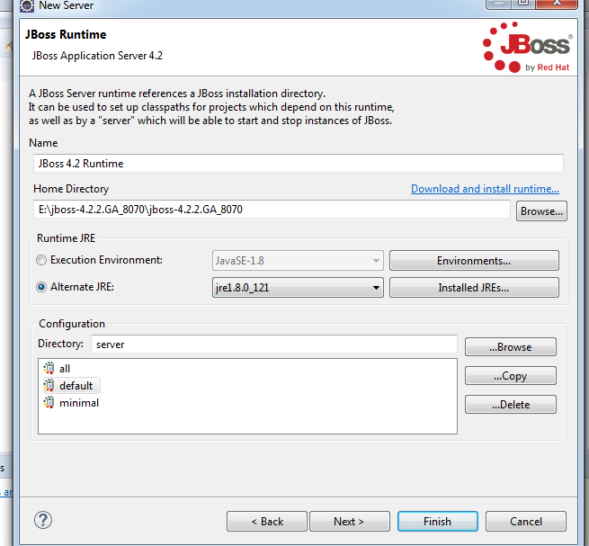

Step 15:

Now increase the Start time in the Timeouts tab to 5000 seconds and change the web port to Jboss’s port.

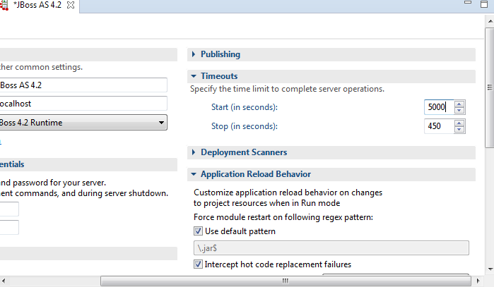

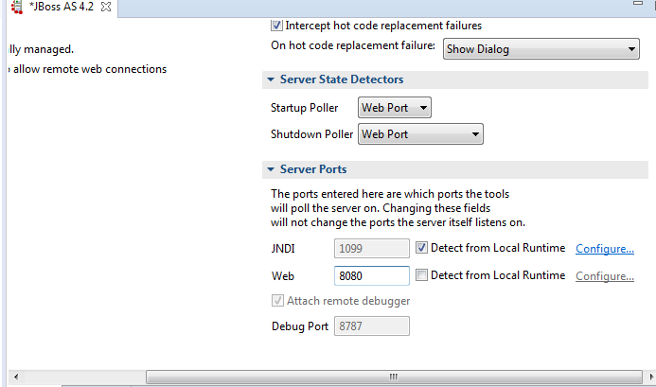

Step 16:

Below is the screen depicts the adding of project to the created Jboss server instance. Right click the newly created Jboss server->select Add and Remove

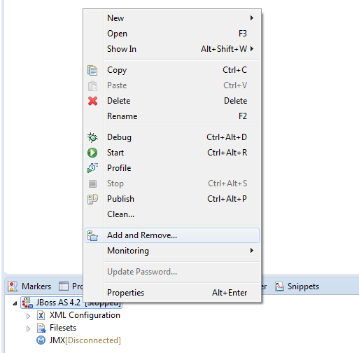

Step 17:

Configure the available project to the server by clicking the Add button and then click Finish button.

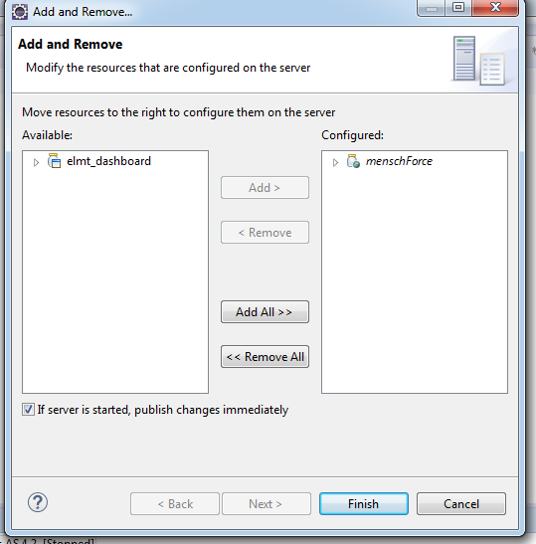

Step 18:

Go to Servers tab where you can see the configured project under Jboss server instance. Once the server is started by clicking the Start button, project is deployed and loaded.

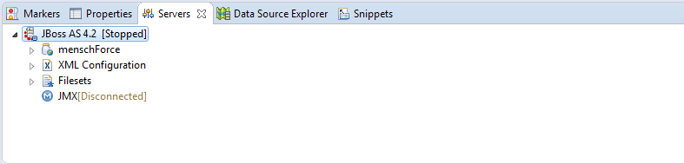

Step 19:

Next to build the project, go to Project tab and select Clean.

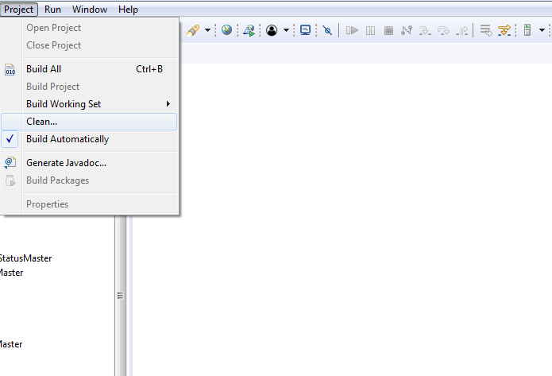

Step 20:

Then check the projects which need to be clean and build and then click Clean.

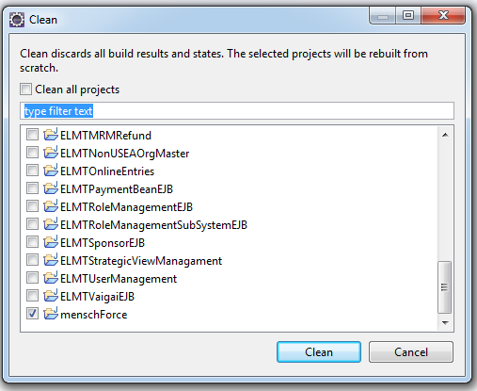

Step 21:

Go to web.xml and mention the initial loading of the page which is loaded when the project is accessed through URL. Once the server is started, the project is loaded with the welcome file which is mentioned in the welcome-file-list tag.

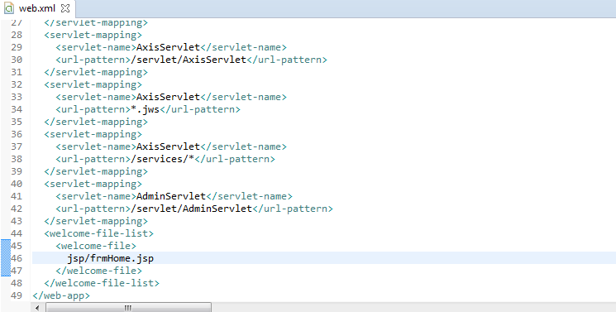

Step 22:

Go to Jboss installed folder, Jboss4.2.2/server/default/deploy/add the respective following ds file.



Step 23:

Edit the ds file accordingly to map with the database connection.

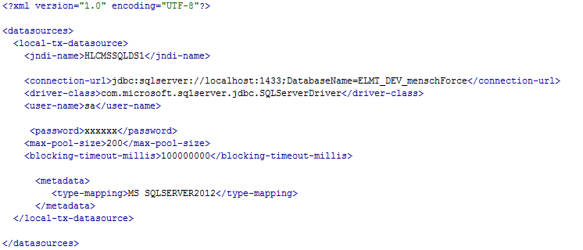

Step 24:

Once the server is started, the project is accessed using the following URL.

http://localhost:8080/klugWerks

